

Asthma Policy January 2024
Review Date Sept 2024
Asthma Lead: TBC

Asthma
Asthma is a condition that affects small tubes (airways) that carry air in and out of the lungs. When a person with asthma comes into contact with something that irritates their airways (an asthma trigger), the muscles around the walls of the airways tighten so that the airways become narrower and the lining of the airways becomes inflamed and starts to swell. Sometimes, sticky mucus or phlegm builds up, which can further narrow the airways. These reactions make it difficult to breathe, leading to symptoms of asthma (Source: Asthma UK).
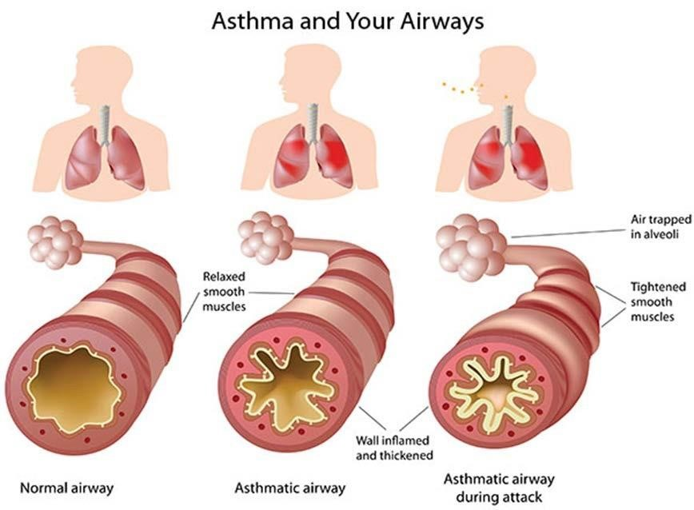

As a school, we recognise that asthma is a widespread, serious, but controllable condition. This school welcomes all pupils with asthma and aims to support these children in participating fully in school life. We endeavour to do this by ensuring we have:
- an asthma register
- up-to-date asthma policy
- an asthma lead
- all pupils with immediate access to their reliever inhaler at all times,
- all pupils have an up-to-date asthma action plan
- an emergency salbutamol inhaler
- ensure all staff have regular asthma training.
- promote asthma awareness pupils, parents and staff.

Asthma Register
We have an asthma register of children within the school, which we update yearly. We do this by asking parents/carers if their child is diagnosed as asthmatic or has been prescribed a reliever inhaler. When parents/carers have confirmed that their child is asthmatic or has been prescribed a reliever inhaler we ensure that the pupil has been added to the asthma register and has:
- an up-to-date copy of their personal asthma action plan,
- their reliever (salbutamol/terbutaline) inhaler in school,
- permission from the parents/carers to use the emergency salbutamol inhaler if they require it and their own inhaler is broken, out of date, empty or has been lost. (see back of policy)

Asthma Lead – TBC
This school has an asthma lead who is named above. It is the responsibility of the asthma lead to manage the asthma register, update the asthma policy, manage the emergency salbutamol inhalers (please refer to the Department of Health Guidance on the use of emergency salbutamol inhalers in schools, March 2015) ensure measures are in place so that children have immediate access to their inhalers.

Medication and Inhalers
All children with asthma should have immediate access to their reliever (usually blue) inhaler at all times. The reliever inhaler is a fast acting medication that opens up the airways and makes it easier for the child to breathe.(Source: Asthma UK).
Some children will also have a preventer inhaler, which is usually taken morning and night, as prescribed by the doctor/nurse. This medication needs to be taken regularly for maximum benefit. Children should not bring their preventer inhaler to school as it should be taken regularly as prescribed by their doctor/nurse at home. However, if the pupil is going on a residential trip, we are aware that they will need to take the inhaler with them so they can continue taking their inhaler as prescribed. (Source: Asthma UK).
Children are encouraged to carry their reliever inhaler as soon as they are responsible enough to do so. We would expect this to be by key stage 2. However, we will discuss this with each child’s parent/carer and teacher. We recognise that all children may still need supervision in taking their inhaler.
School staff are not required to administer asthma medicines to pupils however many children have poor inhaler technique, or are unable to take the inhaler by themselves. Failure to receive their medication could end in hospitalisation or even death. Staff who have had asthma training, and are happy to support children as they use their inhaler, can be essential for the well-being of the child. If we have any concerns over a child’s ability to use their inhaler we will refer them to the Asthma Lead and advise parents/carers to arrange a review with their GP/nurse. Please refer to the medicines policy for further details about administering medicines. (Source: Asthma UK)

Asthma Action Plans
Asthma UK evidence shows that if someone with asthma uses personal asthma action plan they are four times less likely to be admitted to hospital due to their asthma. As a school, we recognise that having to attend hospital can cause stress for a family. Therefore, we believe it is essential that all children with asthma have a personal asthma action plan to ensure asthma is managed effectively within school to prevent hospital admissions. (Source: Asthma UK)
Staff training
Staff will need regular asthma updates.

School Environment
The school does all that it can to ensure the school environment is favourable to pupils with asthma. The school has a definitive no-smoking policy. Pupil’s asthma triggers will be recorded as part of their asthma action plans and the school will ensure that pupil’s will not come into contact with their triggers, where possible.
We are aware that triggers can include:
- Colds and infection
- Dust and house dust mite
- Pollen, spores and moulds
- Feathers
- Furry animals
- Exercise, laughing
- Stress
- Cold air, change in the weather
- Chemicals, glue, paint, aerosols
- Food allergies
- Fumes and cigarette smoke (Source: Asthma UK)

As part of our responsibility to ensure all children are kept safe within the school grounds and on trips away, a risk assessment will be performed by staff. These risk assessments will establish asthma triggers which the children could be exposed to and plans will be put in place to ensure these triggers are avoided, where possible.

Exercise and activity
Taking part in sports, games and activities is an essential part of school life for all pupils. All staff will know which children in their class have asthma and all PE and Outdoor Education teachers at the school will be aware of which pupils have asthma from the school’s asthma register. (Source: Asthma UK)
Pupils with asthma are encouraged to participate fully in all activities. PE/Outdoor Education teachers will remind pupils whose asthma is triggered by exercise to take their reliever inhaler before the lesson, and to thoroughly warm up and down before and after the lesson. It is agreed with PE staff that pupils who are mature enough will carry their inhaler with them and those that are too young will have their inhaler labelled and kept in a box at the site of the lesson. If a pupil needs to use their inhaler during a lesson they will be encouraged to do so. (Source: Asthma UK)
There has been a large emphasis in recent years on increasing the number of children and young people involved in exercise and sport in and outside of school. The health benefits of exercise are well documented and this is also true for children and young people with asthma. It is therefore important that the school involve pupils with asthma as much as possible in and outside of school. The same rules apply for out of hours sport as during school hours PE/Outdoor Education (Source: Asthma UK)
When asthma is effecting a pupil’s education
The school are aware that the aim of asthma medication is to allow people with asthma to live a normal life. Therefore, if we recognise that if asthma is impacting on their life a pupil, and they are unable to take part in activities, tired during the day, or falling behind in lessons we will discuss this with parents/carers, the school nurse, with consent, and suggest they make an appointment with their asthma nurse/doctor. It may simply be that the pupil needs an asthma review, to review inhaler technique, medication review or an updated Personal Asthma Action Plan, to improve their symptoms. However, the school recognises that Pupils with asthma could be classed as having disability due to their asthma as defined by the Equality Act 2010, and therefore may have additional needs because of their asthma.

Emergency Salbutamol Inhaler in school
As a school we are aware of the guidance ‘The use of emergency salbutamol inhalers in schools from the Department of Health’ (March, 2015) which gives guidance on the use of emergency salbutamol inhalers in schools (March, 2015). The document can be found under the downloads for schools section on www.leedswestccg.nhs.uk/childrensasthma. We have summarised key points from this policy below.
As a school we are able to purchase salbutamol inhalers and spacers from community pharmacists without a prescription.
We have 2 emergency kit(s), which are kept in the Medical Room and Outdoor Ed pack so it is easy to access. Each kit contains:
- A salbutamol metered dose inhaler;
- At least two spacers compatible with the inhaler;
- Instructions on using the inhaler and spacer;
- Instruction on cleaning and storing the inhaler;
- Manufacturer’s information;
- A checklist of inhalers, identified by their batch number and expiry date, with monthly checks recorded;
- A note of the arrangements for replacing the inhaler and spacers;
- A list of children permitted to use the emergency inhaler:
- A record of administration
We understand that salbutamol is a relatively safe medicine, particularly if inhaled, but all medicines can have some adverse effects. Those of inhaled salbutamol are well known, tend to be mild and temporary are not likely to cause serious harm. The child may feel a bit shaky or may tremble, or they may say that they feel their heart is beating faster.
We will ensure that the emergency salbutamol inhaler is only used by children who have asthma or who have been prescribed a reliever inhaler, and for whom written parental consent has been given. The schools asthma lead and team will ensure that:
- On a monthly basis the inhaler and spacers are present and in working order, and the inhaler has sufficient number of doses available;
- replacement inhalers are obtained when expiry dates approach;
- Replacement spacers are available following use;
- The plastic inhaler housing (which holds the canister) has been cleaned, dried and returned to storage following use, or that replacements are available if necessary. Before using a salbutamol inhaler for the first time, or if it has not been used for 2 weeks or more, shake and release 2 puffs of medicine into the air
The spacer cannot be reused. We will replace spacers following use. The inhaler can be reused, so long as it hasn’t come into contact with any bodily fluids. Following use, the inhaler canister will be removed and the plastic inhaler housing and cap will be washed in warm running water, and left to dry in air in a clean safe place. The canister will be returned to the housing when dry and the cap replaced.
Spent inhalers will be returned to the pharmacy to be recycled.

The emergency salbutamol inhaler will only be used by children:
• Who have been diagnosed with asthma and prescribed a reliever inhaler OR who have been prescribed a reliever inhaler AND for whom written parental consent for use of the emergency inhaler has been given.
The name(s) of these children will be clearly written in our emergency kit(s). The parents/carers will always be informed in writing if their child has used the emergency inhaler, so that this information can also be passed onto the GP.
Common ‘day to day’ symptoms of asthma
As a school we require that children with asthma have a personal asthma action plan which can be provided by their doctor / nurse. These plans inform us of the day-to-day symptoms of each child’s asthma and how to respond to them in an individual basis. We will also send home our own information and consent form for every child with asthma each school year (see appendix 1). This needs to be returned immediately and kept with our asthma register.
However, we also recognise that some of the most common day-to-day symptoms of asthma are:
- Dry cough
- wheeze (a ‘whistle’ heard on breathing out) often when exercising
- Shortness of breath when exposed to a trigger or exercising
- Tight chest
These symptoms are usually responsive to the use of the child’s inhaler and rest (e.g. stopping exercise). As per DOH document; they would not usually require the child to be sent home from school or to need urgent medical attention.

Asthma Attacks
The school recognises that if all of the above is in place, we should be able to support pupils with their asthma and hopefully prevent them from having an asthma attack. However, we are prepared to deal with asthma attacks should they occur.
All staff will receive an asthma update annually, and as part of this training, they are taught how to recognise an asthma attack and how to manage an asthma attack. In addition guidance will be displayed in the staff room (see appendix 2). This can also be downloaded from
The department of health Guidance on the use of emergency salbutamol inhalers in schools (March 2015) states the signs of an asthma attack are:
- Persistent cough (when at rest)
- A wheezing sound coming from the chest (when at rest)
- Difficulty breathing (the child could be breathing fast and with effort, using all accessory muscles in the upper body)
- Nasal flaring
- Unable to talk or complete sentences. Some children will go very quiet
- May try to tell you that their chest ‘feels tight’ (younger children may express this as tummy ache)
If the child is showing these symptoms we will follow the guidance for responding to an asthma attack recorded below. However, we also recognise that we need to call an ambulance immediately and commence the asthma attack procedure without delay if the child:
*Appears exhausted *is going blue
*Has a blue/white tinge around lips *has collapsed

It goes on to explain that in the event of an asthma attack:
- Keep calm and reassure the child
- Encourage the child to sit up and slightly forward
- Use the child’s own inhaler – if not available, use the emergency inhaler
- Remain with the child while the inhaler and spacer are brought to them
- *Shake the inhaler and remove the cap
- *Place the mouthpiece between the lips with a good deal, or place the mask securely over the nose and mouth
- *Immediately help the child to take two puffs of salbutamol via the spacer, one at a time.(1 puff to 5 breaths)
- If there is no improvement, repeat these steps* up to a maximum of 10 puffs
- Stay calm and reassure the child. Stay with the child until they feel better. The child can return to school activities when they feel better.
- If you have had to treat a child for an asthma attack in school, it is important that we inform the parents/carers and advise that they should make an appointment with the GP
- If the child has had to use 6 puffs or more in 4 hours the parents should be made aware and they should be seen by their doctor/nurse.
- If the child does not feel better or you are worried at ANYTIME before you have reached 10 puffs, call 999 FOR AN AMBULANCE and call for parents/carers.
- If an ambulance does not arrive in 10 minutes give another 10 puffs in the same way
- A member of staff will always accompany a child taken to hospital by an ambulance and stay with them until a parent or carer arrives

• References
- Asthma UK website (2015)
- Asthma UK (2006) School Policy Guidelines.
- BTS/SIGN asthma Guideline
- Department of Health (2014) Guidance on the use of emergency salbutamol inhaler in schools
Appendix 1
School Action Plan Date:
Name:………………………………………………………………………………  Date of birth:…………………………………………………………………….  Allergies:…………………………………………………………………………..  Emergency contact::………………………………………………………..  Emergency contact number …………………………………………...  Doctor’s phone number:………………………………………………….  Class……………………………………………………………………………….. | Affix photo here

What are the signs that your child may be having an asthma attack?

Are there any key words that your child may use to express their asthma symptoms?

What is the name of your child’s reliever medicine and the device?

Does your child have a spacer device? (please circle) Yes No
Does your child need help using their inhaler? (please circle) Yes No

What are your child’s known asthma triggers?

Does your child need to take their reliever medicine before exercise? (please circle) Yes No
If YES, Warm up properly and take 2 puffs (1 at a time) of the reliever inhaler 15 minutes before any exercise unless otherwise indicated below:

I give my consent for school staff to administer/assist my child with their own reliever inhaler as required. Their inhaler is clearly labelled and in date.

Signed………………………………………………. Date………………………………………….

Print Name………………………………………..... Relationship to child………………………………..

CONSENT FORM
USE OF EMERGENCY SALBUTAMOL INHALER

Child showing symptoms of asthma/having asthma attack

- I can confirm that my child has been diagnosed with asthma/has been prescribed an inhaler (delete as appropriate)

- My Child has a working, in-date inhaler, clearly labelled with their name, which they will bring with them to school every day/that will be left at school (delete as appropriate)

- In the event of my child displaying symptoms of asthma, and if their inhaler is not available or is unusable, I consent for my child to receive salbutamol from an emergency inhaler held by the school for such emergencies

Signed Date………………………….

Name (print)……………………………………………………………………………………………….

Relationship to child…………………………………………………………………………………..

Child’s Name………………………………………………………………………………………………

Class…………………………………………………………………………………………………………..

Parent’s address and contact details:

………………………………………………………………………………………………………………….

………………………………………………………………………………………………………………….

Telephone………………………………………………………………………………………………..

Email……………………………………………………………………………….........................

Appendix 2

Symptoms of an asthma attack

- Not all symptoms listed have to be present for this to be an asthma attack
- Symptoms can get worse very quickly • If in doubt, give emergency treatment.
- Side effects from salbutamol tend to be mild and temporary. These side effects include feeling shaky, or stating that the heart is beating faster.

Cough
A dry persistent cough may be a sign of an asthma attack.

Chest tightness or pain

This may be described by a child in many ways including a ‘tight chest’, ‘chest pain’, tummy ache

Shortness of breath

A child may say that it feels like it's difficult to breathe, or that their breath has ‘gone away’

Wheeze

A wheeze sounds like a whistling noise, usually heard when a child is breathing out. A child having an asthma attack may, or may not be wheezing.

Increased effort of breathing

This can be seen when there is sucking in between ribs or under ribs or at the base of the throat. The chest may be rising and falling fast and in younger children, the stomach may be obviously moving in and out. Nasal flaring.

Difficulty in speaking

The child may not be able to speak in full sentences

Struggling to breathe

The child may be gasping for air or exhausted from the effort of breathing

CALL AN AMBULANCE IMMEDIATELY, WHILST GIVING EMERGENCY TREATMENT IF THE CHILD
- Appears exhausted
- Has blue/white tinge around the lips
- Is going blue
- Has collapsed

Administering reliever inhaled therapy through a spacer

A metered dose inhaler can be used through a spacer device. If the inhaler has not been used for 2 weeks then press the inhaler twice into the air to clear it.

  A Spacer might be
  - Orange
  - Yellow
  - Blue
  - Clear
  A spacer may have
  - A mask
  - A mouthpiece

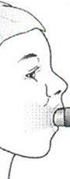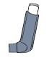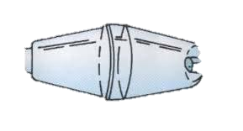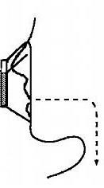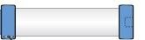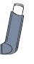

- Keep calm and reassure the child
- Encourage the child to sit up
- Remove cap from inhaler
- Shake inhaler and place it in the back of the spacer
- Place mouthpiece in mouth with a good seal, (or if using the mask place securely over the mouth and nose)
- Encourage the child to breathe in and out slowly and gently
- Depress the canister encouraging the child to continue to breathe in and out for 5 breaths
- Remove the spacer
- Wait 30 seconds and repeat steps 2-6
- Assess for improvement in symptoms

Dependent on response steps 2-7 can be repeated according to response up to 10 puffs.

If there is no improvement CALL 999. If help does not arrive in 10 minutes give another 10 puffs in the same way.

If the child does not feel better or you are worried ANYTIME before you have reached 10 puffs, call 999 for an ambulance and continue to treat as above.

