UKS2A | Autumn 1 | Autumn 2 | Spring 1 | Spring 2 | Summer 1 | Summer 2
School Values | 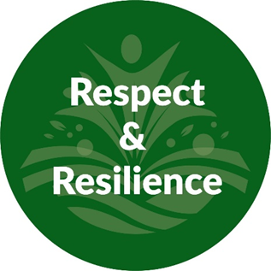 |  | 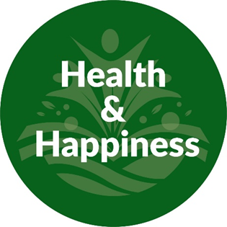 |  | 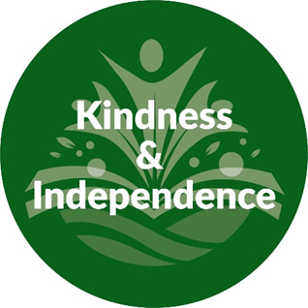
Mental Health and Wellbeing  (Whole School Approach) | 10-a-day Mental Health Choices; https://www.normalmagic.co.uk/resources/10-a-day-2/  Kindness Calendar; https://www.redcross.org.uk/get-involved/teaching-resources/kindness-calendar  Action for happiness; https://actionforhappiness.org/  Normal Magic; https://www.normalmagic.co.uk/  Happy Maps; https://happymaps.co.uk/  Mentally Healthy Schools; https://www.mentallyhealthyschools.org.uk/resources/  Creative education; https://www.creativeeducation.co.uk/  Young Minds; https://www.youngminds.org.uk/ |  |  | 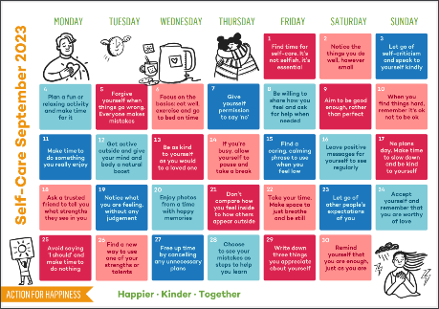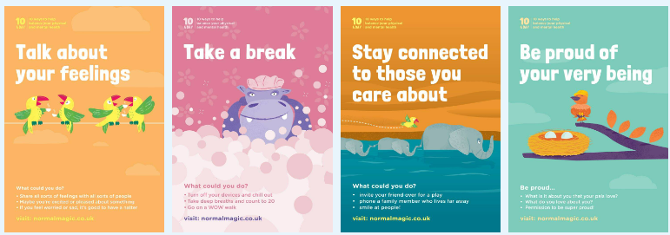
Termly and Assembly Themes | Respect | Resilience | Health | Happiness | Kindness | Independence
Skills Builder  Step 2 | 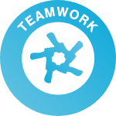 |   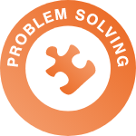 |  | 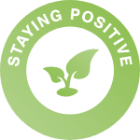 | 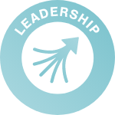  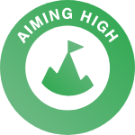 | 
Early Literacy approaches / Phonics | https://educationendowmentfoundation.org.uk/education-evidence/early-years-toolkit/early-literacy-approaches  Pupils whose reading and writing is not yet fluent and effortless will have access to specified interventions that; Provide practical support and high-quality teaching of systematic synthetic phonics (SSP)  Delivered via Read Write Inc. sessions with activities that aim to develop letter knowledge, knowledge of sounds and early phonics. https://www.ruthmiskin.com/  Class / Small group reading, Introductions to different kinds of writing.  Whole school culture motivates pupils to develop a love of reading.
 | Autumn 1  Pyramids and Towers | Autumn 2  Stargazers | Spring 1  Traders and Raiders | Spring 2  Rainforests | Summer 1  Make it Big! | Summer 2  Magic and Enchantment
Class Novel | 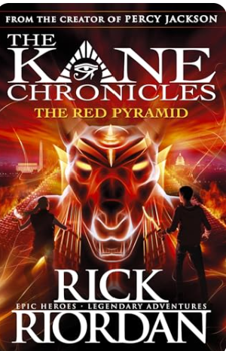 | 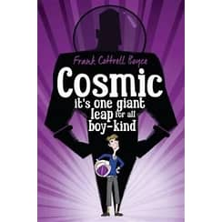 | 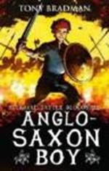 | 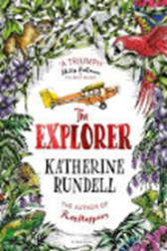 | 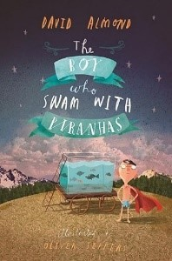 | 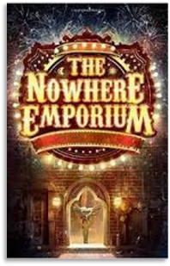
Focus Text | 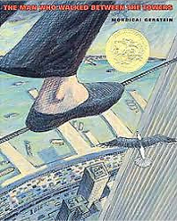 | 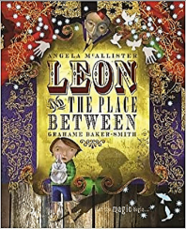 | 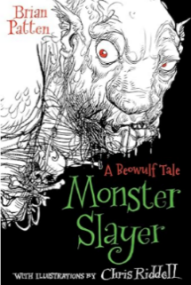  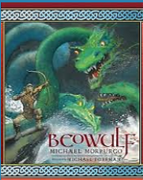 |  | 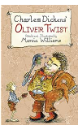
Non-Fiction | 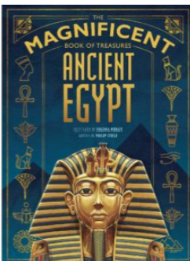 | 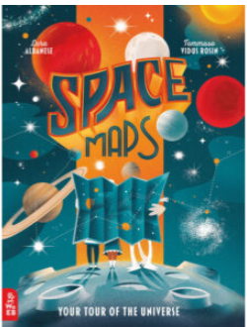 | 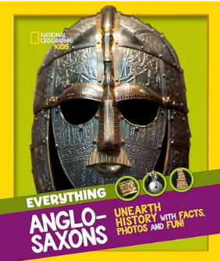 | 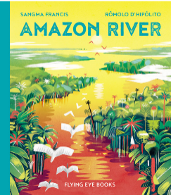 | 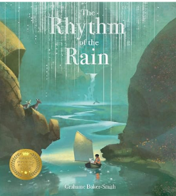 | National Geographic Kid’s  The Frog Life Cycle for Kids - National Geographic Kids (natgeokids.com)
Additional Texts |  | 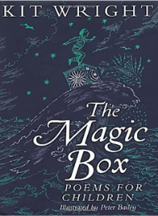 | 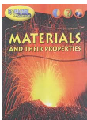 | I wanna iguana  https://www.youtube.com/watch?v=X7dswe0DuDU  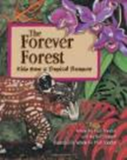 | Theme Park Literature  
Writing:  Fiction | Retells & Recounts – what makes a narrative  Outcome: Warning Tale  Focus: Tell it in 5, characters | Science Fiction  Outcome: Illustrated Fantasy Story  Focus: Settings: 5 senses | Beat the Monster story  Outcome: Anglo-Saxon Saga for class short story anthology  Focus: Different sentence types | Fiction: Retell Story in more detail  Outcome: Descriptive writing  Focus: Developing character and setting  subordinate clauses, e.g. because he was hungry. | Change story  Outcome: PowerPoint story  Focus: Openings and endings | Fantasy Story  Outcome: Book for class collection  Focus: Flashback, Expanded noun phrases
Writing Fiction  Non-Fiction | Information text  Outcome: Leaflet about Forces  Focus: Reader Hooks. paragraphs  Journalistic Writing: Report  Outcome: Eyewitness report  Focus: conjunctions | Non-chronological Report  Outcome: Earth and Space Report  Focus: Organisational Devices: Using headings, sub-headings, captions | Non-chronological report  Outcome: Anglo-Saxons class book  Focus: Organisational Devices: Using headings, sub-headings, captions | Persuasive Letter  Outcome: Letter asking parent for a pet  Focus: Persuasive language | Persuasive writing  Outcome: Advertisement leaflets for theme park  Focus: Persuasive language | Explanation text: Lifecycle  Outcome: Lifecycles Poster  Focus: Adjectival phrases
Writing:  Poetry | Cinquain  Focus: Rhyme and Structure poem (ABCB poem) |  |  | Concrete Poetry  Focus: Typographical effect Verse structure
Maths | Number  Place Value  Addition and Subtraction | Number  Multiplication and Division  Fractions | Number  Decimals and Percentages  Measurement  Perimeter and Area  Statistics | Number  Multiplication and Division  Fractions | Number  Decimals  Measurement  Converting Units  Volume | Geometry  Property of Shape  Position and Direction
Science | Physics: Forces | Physics: Earth  Sustainability: Global; Warming | Chemistry: Properties of Materials | Biology: Animals including Humans | Biology: Reproduction A | Biology: Reproduction B
Academic Interventions will be implemented where necessary to aid pupil progress, plug gaps in learning and secure good outcomes against individual pupils starting points.
Interventions such as Phonics via RWI, games-based literacy and numeracy interventions, Fun Fit, Touch Typing.
Therapies  SALT Communication & Interaction | Class Reading  Social Situations  Games: Board and Cards: Uno  Team Building  Every pupil can have access to; (*Therapeutically inspired interventions, these will be based on individual need, informed by professional advice and parental guidance please see interventions provision map)  Trauma Informed approach  Individually assessed sensory integration regulation activities  TEEACH approach
Word of the Week | Yearn  Serene  Nostalgic  Innovative  Uncanny  Scour | Constrict  Accumulate  Inflate  Diminish  Lucid  Dubious | Perilous  Supercilious  Treacherous  Disposition  Tremor  Perusal | Arduous  Swathe  Derisory  Fleeting  Vigilant  Tremulous | Trajectory  Reciprocate  Poignant  Zeal  Forlorn  Contentious | Enchantment  Misanthropic  Auspicious  Acquire  Periphery  Fractious
Idiom of the Week | Eager Beaver  Down in the dumps  Think outside the box  Bury the hatchet  Money doesn’t grow on trees  On the cards | In a pickle  In the same boat  Achille’s Heel  Put your money where your mouth is  Break a leg  Turn over a new leaf | Put all your eggs in one basket  Cry over spilled milk  On the back burner  Mend fences  Eat humble pie  Jump on the bandwagon | The gloves are off  Midas touch  Hold your horses  Cost an arm and a leg  Throw in the towel  Ball is in your court | Have a lot on your plate  Spill the beans  Take a rain check  Call the shots  Midas touch  In a nutshell | Get cold feet  Piece of cake  Couch potato  A taste of our own medicine  A fish out of water  Money can’t buy happiness
Interoception Curriculum | Section 1 Body | Section 1 Body | Section 1 Body  Section 2 Emotions | Section 2 Emotions | Section 2 Emotions | Section 2 Emotions
Personal Development / PSHE |    | 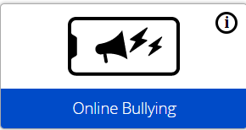  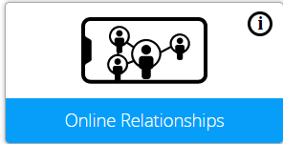  Anti-Bullying week: Online bullying  https://anti-bullyingalliance.org.uk/ | 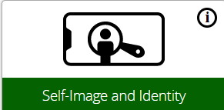  Safer Internet Day:https://saferinternet.org.uk/ | 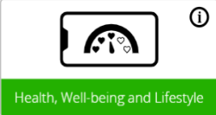 |  |   CSE Awareness Day  https://stop-cse.org/national-child-exploitation-awareness-day/
Online Safety  Project Evolve | Managing Online Information  Different types of search technologies  Being sceptical  Evaluating online content  Privacy and Security  Email Passwords  Connectivity  Data Handling of Users  Data Backup  Online payments  Online Terms and Conditions  Tracking | Online Bullying  Bullying – physical & online  Banter or bullying  Getting help  Reporting concerns  Blocking  Online Relationships  Choice  Influence – negativity  Online Trust  Harmful online behaviour | Self-image & Identity  Positive self-promotion  Digital identity | Copyright & Ownership  Using others work  Content permissions | Health, Wellbeing and Lifestyle  Technology – affecting health  Promoting health & wellbeing | Online Reputation  Searching online for individuals  Judging others online
PSHE | What jobs would we like?  Careers; aspirations; role models; the future | What makes up our identity?  Identity; personal attributes and qualities; similarities and differences; individuality; stereotypes | How can we help in an accident or emergency?  Basic first aid, accidents, dealing with emergencies | How can friends communicate safely?  Friendships; relationships; becoming independent; online safety | How can drugs common to everyday life affect health?  Drugs, alcohol & tobacco; healthy habits | What decisions can people make with money?  Money; making decisions; spending & saving
Personal Development /  PSHE including; National Awareness | Great British Beach Clean 2024  World - Let's Stop Shouting Day 2024  Health & Wellbeing -  Age | Anti bullying Week; https://anti-bullyingalliance.org.uk/  Relationships – Diversity  Sex  Sexual Orientation | Safer Internet day; https://www.saferinternetday.org/  CSE awareness day; https://stop-ce.org/national-child-exploitation-awareness-day/  Relationships – Building Relationships Marriage and Civil Partnerships  Gender Re Assignment Pregnancy and Maternity | Health & Wellbeing – Health & Puberty  Race | Living in the wider world – Financial Decision Making  Disability | Living in the wider world – Developing skills & Aspirations  Personal Safety  Religion and Beliefs
PSHE  Protected Characteristics | Race  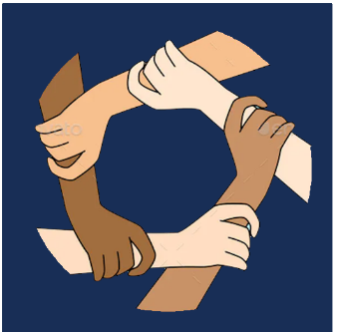 | Sex    Sexual Orientation   |   Marriage and Civil Partnerships  Pregnancy and Maternity   | Age    Gender Reassignment   |   Disability | Religion and Beliefs  
PSHE  British Values | Mutual Respect |  | Rule of Law | Individual Liberty | Tolerance | Democracy
ASDAN Personal Development | Making a Sandwich  LC 3389  E1 | Going Shopping  LC: 1890  E1  Making items using air dry clay  LC 4755  E2 | Personal Appearance and Hygiene  LC 4777  E3 | Road Safety Awareness  LC 5382  E2 | Growing a kitchen garden  LC5435  E2 | Using Transport  LC1237  WTE1  Using Public Transport  LC 4918  E1
Careers | Skills builders career challenge - Listening | The Fiver Challenge from Young Enterprise  Public Sector  Emergency Services: Lifeguards & Coast Rescue | Skills builders career challenge - Creativity | Economies Sector  Visit: Newquay  Careers Fair | Skills builders career challenge - Leadership | Public and Private sector  What are the roles in these sectors?  Careers Professional Presentations
Computing | Computing Systems & Networks – Systems & Searches | Creating Media – Video Production | Programming A – Selection in Physical Computing | Data & Information – Flat File Database | Creating Media – Introduction to Vector Graphics | Programming B – Selection in Quizzes
RE | Christianity  U2.2 Creation and Science: conflicting or complimentary? | Christianity  U2.3 Why do Christinas believe that Jesus is the Messiah? | Christianity  U2.4 How do Christinas decide to live? ‘What would Jesus do?’ | Christianity  U2.5 What did Christians believe Jesus did to ‘save’ people? | World Views  U2.12 How does faith help people when life gets hard? | Hinduism  U2.7 Why do Hindus try to be good?
Home Cooking Skills | Breakfast & Brunch:  Fruity Fare | Pastry & Bread:  Shortcrust Pastry | Just Desserts:  Pudding or Cake? | It’s all about the Carbs!  Bread | What’s for Dinner?  Pasta | Alfresco Dining & Drinks  Sandwiches
Humanities | What do we know about the Ancient Egyptians? | Who was the most successful Henry VIII or Elizabeth I? | Who were the Anglo-Saxons? | Why should the rainforests matter to all of us? | Mapping Skills  Where and what are the names of the oceans and seas of the world? | Where are we in the world now?  Mapping Skills
Art  DT | 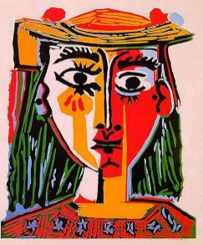  Who Am I? Colour theory and exploration. Picasso |  | 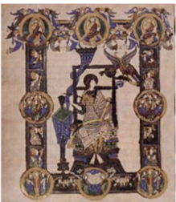  Art in History: Printing Anglo-Saxon pattern Work |  | 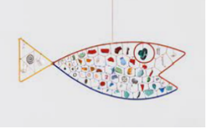  3D Sculpture: Collage, Weaving, Stitching  Alexander Calder
PE | Net & Wall Games: Badminton  Invasion Games:  Hockey | Gymnastics: Jumps & Inverted Movements  Invasion Games: Tag Rugby  Indoor Swimming | Dance: Relationships & Performance  Invasion Games: Basketball | Yoga: Strength & Mindfulness  Fitness: Strength & Stamina | Athletics: Running, throwing, jumping  Swimming & Water Safety | Games: Striking & Fielding: Rounders  Net & Wall Games: Tennis
Outdoor Education | Forest Skills  Orienteering - Designing Trails  Animal Trail/ Bug Spotting  Indoor Swimming |  |  | Nature in our community  Newquay Zoo  Beach combing  Frogpool Park | Forest School  Team building challenges  Coastal Swimming | Water Adventures  Wild Swimming-Beach & River  SUP/ Canoe  Outdoor Education Learning Award

