Year 9 | Autumn 1 | Autumn 2 | Spring 1 | Spring 2 | Summer 1 |  | Summer 2
School Values | 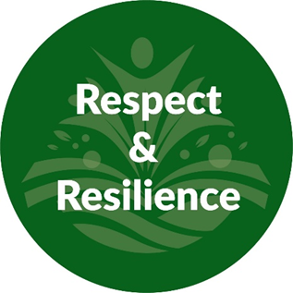 |  |  |  | 
Mental Health and Wellbeing  (Whole School Approach) | 10-a-day Mental Health Choices; https://www.normalmagic.co.uk/resources/10-a-day-2/  Kindness Calendar; https://www.redcross.org.uk/get-involved/teaching-resources/kindness-calendar  Action for happiness; https://actionforhappiness.org/  Normal Magic; https://www.normalmagic.co.uk/  Happy Maps; https://happymaps.co.uk/  Mentally Healthy Schools; https://www.mentallyhealthyschools.org.uk/resources/  Creative education; https://www.creativeeducation.co.uk/  Young Minds; https://www.youngminds.org.uk/ |  |  | 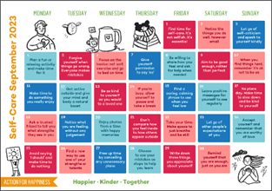
Termly and Assembly Themes | Respect | Resilience | Health | Happiness | Kindness |  | Independence
Skills Builder  Step 5 |  |    |  |  |    |  | 
 | Autumn 1  Respect | Autumn 2  War and Conflict | Spring 1  End of the World | Spring 2  Dystopian World | Summer 1  Survival |  | Summer 2  Rags to Riches
Challenge Novel | 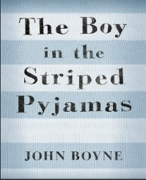 |  | 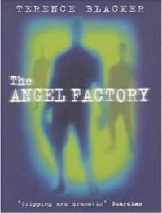 |  | 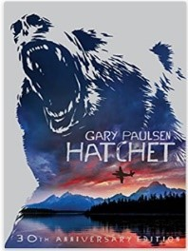 |  | 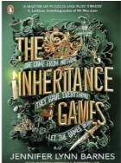
Focus Text | 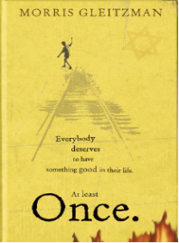 | 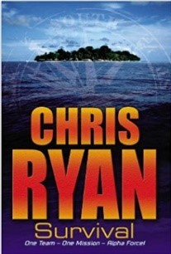 | 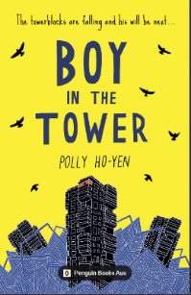 | 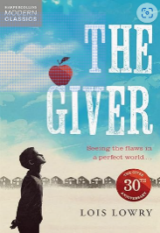 | 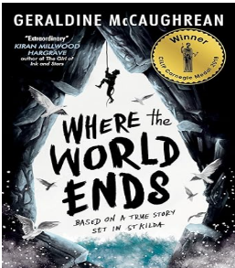 |  | 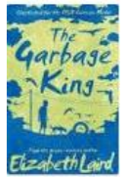
Non-Fiction |  |  | 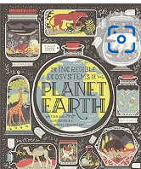 |  |  |  | 
Additional Texts |  | The Piano Aidan Gibbons  The Piano by Aidan Gibbons (youtube.com) |  |  | 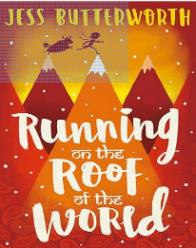  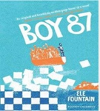
English | Respect  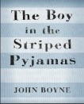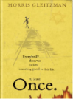 |  | Animal Farm (If studying English Double, Lit and Lang) |  | Macbeth (If studying English Double, Lit and Lang)
Writing:  Fiction | Quest  Outcome: Audio book for school website  Focus: Endings | Historical  Outcome: Voiceover for Aidan Gibbons: The Piano  Focus: Flashback | Suspense with a portal  -structure  Outcome: Sway story (mix of writing and images)  Focus: Dialogue with full punctuation " " , . | Short story: Dystopian World  Outcome: Class collection of short stories  Focus: Developing characterisation | Journey Story  Outcome: Surviving a Journey Podcast  Focus: openers, sentence variety, paragraphs |  | Portal story  Outcome: (Using Shaun Tan examples etc)  Picture book for teenagers  Focus: vocabulary choice
Writing: Non-Fiction | Non-chronological report: Holocaust  Outcome: Webpage article about Holocaust Survivors for Newsletter  Focus: Varying sentence length for effect | Explanation Text: Survival  Outcome: IT produced leaflet  Focus: Imperatives | Explanation about physical environments  Outcome: online magazine article about Polar and Tundra/ Deserts (Teacher model Savannah)  Focus: Expanded noun phrases | Prepare a speech to launch a debate  Outcome: speech from a given viewpoint  Focus: Point and Evidence structure | Biography of Bear Grylls  Outcome: Comic strip as part of a newly launched survival skills magazine  Focus: Subordinate clauses
Writing: Poetry | Imagery in poems – using images of holocaust victim’s belongings | War poetry  Poem: Experience of war  Outcome: voiceover on an image of war |  |  | 375 Poems by William Shakespeare
Maths | Straight Line Graphs  Numbers  Forming and Solving Equations | Testing Conjectures  Using Percentages  Maths and Money | Enlargement and Similarity  Solving Ratio and Proportion Problems  Probability | Algebraic Representation  Number and Measure Exam  Or/And  Functional Skills and Problem Solving |  | Number and Measure Exam  Or/And  Functional Skills and Problem Solving  Deduction  Constructions and Congruency | Three Dimensional Shapes  Rotation and Translation  Rates
Science | Genes: Evolution  Electromagnetism: Electromagnets | Ecosystems: Photosynthesis  Forces: Contact Forces  Forces: Pressure | Reactions: Chemical energy  Reactions: Types of reaction | Energy: Work  Earth: Climate | Genes: Inheritance  Earth: Earth resources |  | Waves: Wave effects  Waves: Wave properties
Academic Interventions | Academic Interventions will be implemented where necessary to aid pupil progress, plug gaps in learning and secure good outcomes against individual pupils starting points.  Interventions such as Phonics via RWI, games-based literacy and numeracy interventions, Fun Fit, Touch Typing.
Therapies  SALT Communication & Interaction | Class Reading  Social Situations  Games: Board and Cards: Uno  Team Building  Every pupil can have access to; (*Therapeutically inspired interventions, these will be based on individual need, informed by professional advice and parental guidance please see interventions provision map)  Trauma Informed approach  Individually assessed sensory integration regulation activities  TEEACH approach
Word of the Week | Yearn  Serene  Nostalgic  Innovative  Uncanny  Scour | Constrict  Accumulate  Inflate  Diminish  Lucid  Dubious | Perilous  Supercilious  Treacherous  Disposition  Tremor  Perusal | Arduous  Swathe  Derisory  Fleeting  Vigilant  Tremulous | Trajectory  Reciprocate  Poignant  Zeal  Forlorn  Contentious |  | Enchantment  Misanthropic  Auspicious  Acquire  Periphery  Fractious
Idiom of the Week | Eager Beaver  Down in the dumps  Think outside the box  Bury the hatchet  Money doesn’t grow on trees  On the cards | In a pickle  In the same boat  Achille’s Heel  Put your money where your mouth is  Break a leg  Turn over a new leaf | Put all your eggs in one basket  Cry over spilled milk  On the back burner  Mend fences  Eat humble pie  Jump on the bandwagon | The gloves are off  Midas touch  Hold your horses  Cost an arm and a leg  Throw in the towel  Ball is in your court | Have a lot on your plate  Spill the beans  Take a rain check  Call the shots  Midas touch  In a nutshell |  | Get cold feet  Piece of cake  Couch potato  A taste of our own medicine  A fish out of water  Money can’t buy happiness
Interoception Curriculum | Section 1 Body | Section 1 Body | Section 1 Body  Section 2 Emotions | Section 2 Emotions | Section 2 Emotions |  | Section 2 Emotions
Personal Development / PSHE |    | 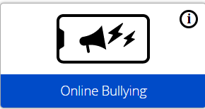  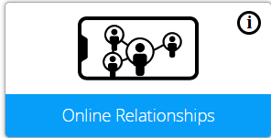  Anti-Bullying week: Online bullying  https://anti-bullyingalliance.org.uk/ |   Safer Internet Day: https://saferinternet.org.uk/ |  |  |  |   CSE Awareness Day  https://stop-cse.org/national-child-exploitation-awareness-day/
Online Safety  Project Evolve | Managing Online Information  Social Media - Extremism  Misinformation & Social Bots  Deepfake Technology  Privacy and Security  Controlling Personal Data  Device & Account Recovery  Hacking & Cyber Problems | Online Bullying  Unpleasant Escalation  Disinhibition  Reporting Bullying  Online Laws – Behaviour & Bullying  Online Relationships  Harmful Online Sexual Behaviour  Online Laws | Self-image & Identity  Online images – reinforcing stereotypes.  Online Pressures  Digital Manipulation | Copyright & Ownership  Creative Commons Licensing protocols.  Copyright Theft | Health, Wellbeing and Lifestyle  Promotion of Unhealthy Coping Strategies – Risks, Support & Reporting |  | Online Reputation  Monitor & Manage Online Reputation  Key Laws governing online behaviour & reputation
PSHE | Respectful Relationships  Families and parenting, healthy relationships, conflict resolution, and relationship changes | Peer Influence, Substance Use & Gangs  Healthy and unhealthy friendships, assertiveness, substance misuse, and gang exploitation | Healthy Lifestyle  Diet, exercise, lifestyle balance and healthy choices, and first aid | Intimate Relationships  Relationships and sex education including consent, contraception, the risks of STIs, and attitudes to pornography | Setting Goals  Learning strengths, career options and goal setting as part of the accreditation pathway |  | Employability Skills  Employability and online presence
PSHE  Protected Characteristics | Race   | Sex    Sexual Orientation   | Marriage and Civil Partnerships    Pregnancy and Maternity   | Age    Gender Reassignment   | Disability   |  | Religion and Beliefs  
PSHE  British Values | Mutual Respect |  | Rule of Law | Individual Liberty |  | Tolerance | Democracy
ASDAN Personal Development  Bronze | Module 1  Communication  A2 Obtain information in different ways.  A5 Find out how to use a piece of equipment.  A7 Plan journeys using a map  M6A6 Plan a journey by public transport. To be completed together  A8 obtain information from different sources. | Module 2  My community  B3 Raise funds for a charity or cause. | Module 11  Number Handling  6A1 Compare the cost of different brand options  6A4 Plan the cost of a birthday celebration  6A6 Plan a journey by public transport  6A9 Make a weekly shopping list for one person. | Module 5  My Environment  B2 Improve the look of a garden | Module 10  The Wider World  B1 Produce in depth study of another county. |  | Module 4  Independent Living  A3 Clean and tidy a room  A4 Wash and iron your clothes  A5 Make a list of emergency contacts numbers.  A6 Show how you recycle items
Careers | Focus  Business Structure -  Creating a brand | Focus  Enterprise Skills – How do these skills make you more employable?  Skills builder Challenge Day  ASDAN Personal Development  Module 8 World of work | Focus  Tenner Challenge – Creating my own business. | Focus  Tenner Challenge – Developing a financial plan and managing business finances. | Focus  Personal Finances – How do I manage my finances? Setting up a bank account, personal finance and investing |  | Focus  Creating Opportunities – Developing a CV.  University Visit  Skills builder Challenge Day  ASDAN Personal Development Module 8 World of Work
Computing | Representations – going audio-visual | Python Programming with Sequences of Data | Media- Animations | Data science | Cybersecurity |  | Physical Computing
RE | Christianity  3.7 What is so radical about Jesus? | World Views  3.15 How far does it make a difference if you believe in life after death? | Judaism  3.11 What is good and what is challenging about being a Jewish teenager in Britian today? | World Views  3.13 What difference does it make to be atheist or agnostic in Britain today? | World Views  3.16 Why is there suffering? Are there any good solutions |  | World Views  3.17 Should Happiness be the purpose for life?
Home Cooking Skills | Breakfast &Brunch:  Breakfast Eggs | Pastry & Bread:  Scrumptious Savouries | Just Desserts:  Bella Italia! Too full for Dessert | It’s all about the Carbs!  Try them All! | What’s for Dinner?  Level 1 Assessments |  | Alfresco Dining & Drinks  Drink & a Treat!
Humanities | World History  Understanding the modern world, 1900-present | Geographical Enquiry  Why is the Middle East an important world region? | British History  Understanding industry and empire,  1750-1900 | Physical Geography  Climate Change and the Earth’s future | Physical Geography  Can we ever know enough about volcanoes to live safely? |  | British History  Migration to Britain through Time
Art | The world around me: Street / local area observations: Banksy, and other street artists. Mixed media project.  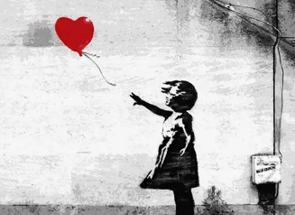 |  | An exploration of Fauvism: Henri Matisse  Students can choose to explore landscapes or self-portrait based on the theme.  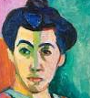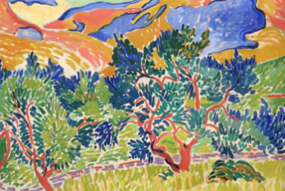 |  | 3D Sculptural exploration from Cornish Landscapes:  Peter Lanyon  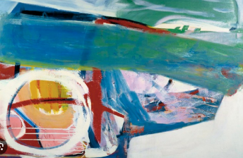
PE | Games: Net and Striking: Badminton  Target Games; Dodgeball | Fitness: Gym Suite &  Circuit Training  Invasion Games:  Bench ball & Handball | Gymnastics: Vaulting  Net & Wall Games: Table Tennis | Invasion Games: Football  Net & Wall Games: Table Tennis | Games: Striking and Fielding  Cricket  Target Games: Boccia |  | Athletics: Running, throwing, jumping
Outdoor Education | Watersports SUP/Canoe Skills  Wild Swimming | Forest School  Shelter building, cooking, survival skills  Duke of Edinburgh Award  Bronze level | Forest Skills  Mountain Biking  Clip & Climb  Caving  Indoor Swimming | Adventure Activities  Climbing Wall  Outdoor Ed centre activities  Sailing  Duke of Edinburgh Award Expedition | Forest School  Team building challenges  Coastal Swimming |  | Water Adventures  Wild Swimming-Beach & River  SUP/ Canoe  Outdoor Education Learning Award

