Year 11 | Autumn 1 | Autumn 2 | Spring 1 | Spring 2 | Summer 1 | Summer 2
School Values | 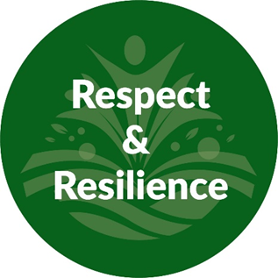 |  |  |  | 
Mental Health and Wellbeing  (Whole School Approach) | 10-a-day Mental Health Choices; https://www.normalmagic.co.uk/resources/10-a-day-2/  Kindness Calendar; https://www.redcross.org.uk/get-involved/teaching-resources/kindness-calendar  Action for happiness; https://actionforhappiness.org/  Normal Magic; https://www.normalmagic.co.uk/  Happy Maps; https://happymaps.co.uk/  Mentally Healthy Schools; https://www.mentallyhealthyschools.org.uk/resources/  Creative education; https://www.creativeeducation.co.uk/  Young Minds; https://www.youngminds.org.uk/ |  |  | 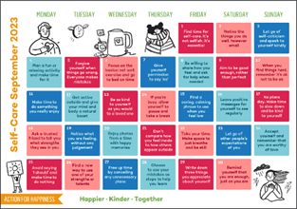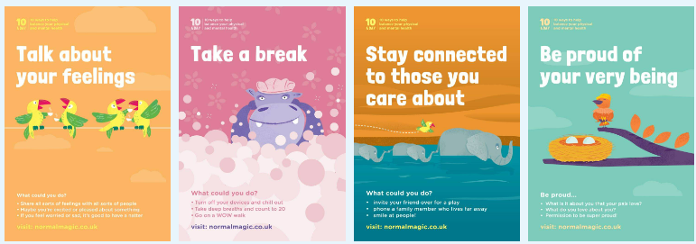
Termly and Assembly Themes | Respect | Resilience | Health | Happiness | Kindness | Independence
Skills Builder  Step 7 |  |    |  |  |    | 
Year 11 | Autumn 1  Life under the Microscope | Autumn 2  Crime in the USA | Spring 1  Modern and Victorian Crime | Spring 2  Apocalyptic World | Summer 1  Extracts | Summer 2  New Beginnings
Class Novel | 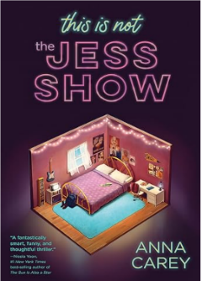 | 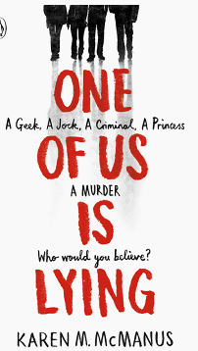 | 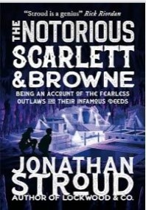 | 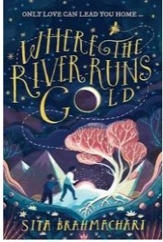 | Extracts from magazines and newspaper | 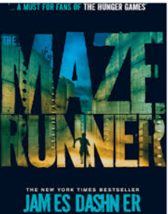
Focus Text | 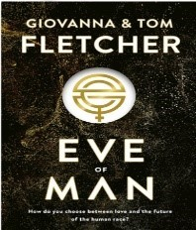 | 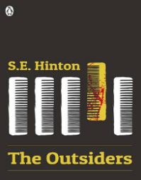 | 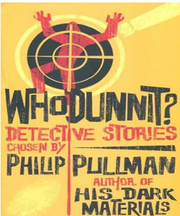 | 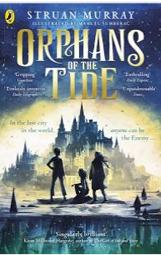 | Extracts from Syllabus | 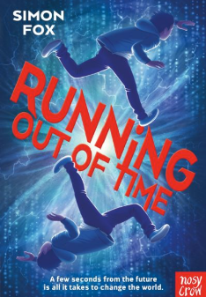
Additional Texts | Film: The Truman Show | 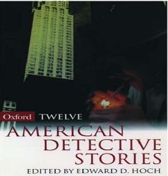  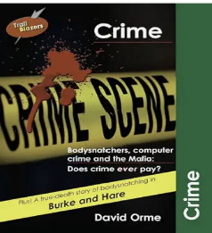 | 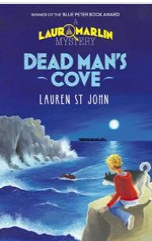  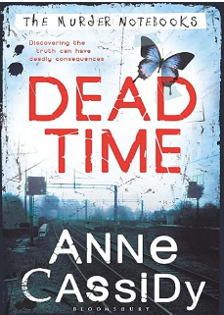
Hybrid Texts |  |  | 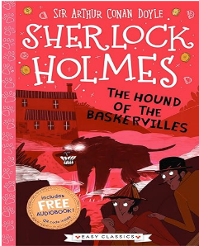 | 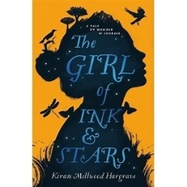 | Extracts from Syllabus | 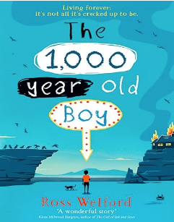
Step Up Gold | Gothic Horror  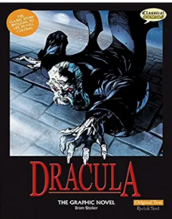  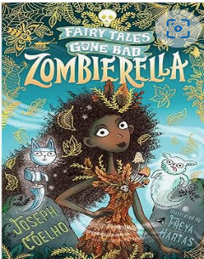 | Crime  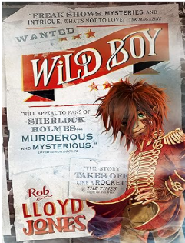 | Dystopia  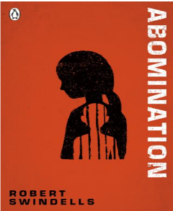 | Pets  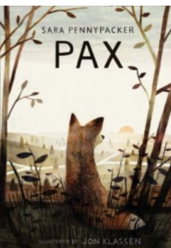 | Holidays  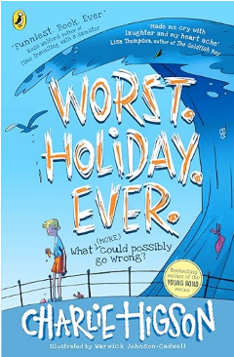 | Leavers Piece
English Double Lit and Lang | Practice and Technique. Language Paper 2. Revision for mocks: Language Paper 2 and Literature Paper 1  Poetry and Short Stories. Range of texts are explored in this unit for the purpose of analysing writer's craft. |  | Poetry and Short Stories  Range of texts are explored in this unit for the purpose of analysing writer's craft. |  | Series of revision sessions to suit all year 11 learners and their individual year 11 pathway.
Writing:  Narrative/ Creative | Descriptive Writing  Outcome: Description about visiting the setting in Eve of Man  Focus: Setting &  Flashback writing | Descriptive Writing  Outcome: Diary account of arrest and being locked in a cell  Focus: Modal verbs, Narration | Narrative  Outcome: Mystery story  Including flashback  Focus: Personification | Descriptive Writing  Outcome: Describe an animal using the senses  Focus: stylistic devices | Narrative  Outcome: Short story responding to a starter | Leavers pieces reporting what they have enjoyed at CCS.
Writing:  Non-fiction/  Transactional | Balanced Argument  Outcome: Ethics of the Truman Show  Focus: Paragraphs | Non-chronological Report  Outcome: Witness Crime Report  Focus: Active voice | Explanation  Outcome: Presentation: Explanation of who you think is the perpetrator and why. | Letter  Outcome: to an MP/ councillor/ public figure about an issue related to climate change.  Focus: Persuasive style  Persuasive letter  Persuasive article for the school newsletter: advocate greener school policies  Outcome:  Focus: Subjunctive using were and would  Balanced argument  Outcome: Animal experiments  Focus: Sentence openers | Persuasion  Outcome: letter of complaint  Focus: Sentence Openers  Non-chronological Report  Outcome; Tourist Information Presentation  Focus: Punctuation | Memory boxes of important things from their time at CCS
Writing:  Step Up  Entry Level | Gothic Horror  Narrative  Outcome: Gothic Horror Story  Focus: Similes and Metaphors | Crime  Chronological Report  Outcome: Witness statement  Focus: First person, temporal markers  Narrative  Outcome: Suspense Crime Story  Focus: Adverbs, adjectives | Dystopia  Outcome: Character Portrait  Focus: Powerful Vocabulary  Outcome: A Dystopian Story  Focus: Punctuation, openings, adverbs, adjectives | Pets  Persuasion  Outcome: Pet Advert Poster  Focus: Vocabulary choices  Outcome: Blog  Focus: punctuation, vocabulary choice | Holidays!  Non-chronological Report  Outcome; Tourist Information Presentation  Focus: Punctuation  Persuasion  Outcome: letter of complaint  Focus: Sentence Openers | Leavers pieces reporting what they have enjoyed at CCS  Memory boxes of important things from their time at CCS
Year 11  Foundation GCSE | Circles, π – label, circumference, area, arc lengths, sectors  3D shapes – names, properties, surface area, nets, volumes | Projections – plans and elevations  Isometric paper and 3D drawing  Angles – types, measuring, rules, parallel lines, geometry problems  Angles in polygons  Triangle constructions  Loci and constructions | Bearings  Maps and scale drawings  Pythagoras’ Theorem  Vectors  Probability – scales, list outcomes, frequency, and/or tree diagrams | Sets and Venn diagrams  Sampling and bias  Collecting data  Mean, median, mode, range  Averages from tables  Interpret and compare data  Trigonometry | Revision  Exam Preparation | Revision  Exam Preparation
Year 11  Higher GCSE | Circles – area of segments  Volumes of frustums  Rates of flow | Enlargement for area and volume | 3D Pythagoras’  Vectors – extension and ratio  Product rule to count outcomes  Probability – extension for tree diagrams and conditional probability | Box plots  Cumulative frequency  Histograms and frequency density  Moving average  Sine and cosine rule  3D Trigonometry | Revision  Exam Preparation | Revision  Exam Preparation
Year 11  Entry Level 2 | Numbers and the Number system  Order numbers up to 200  Odd and even  Recognise and interpret four rule symbols  Add and subtract two-digit numbers  Multiplication  Weeks and years | Numbers and the Number system  Division with remainders  Rounding  Fractions  Decimals | Using common measures, shape and space  Money  Time – analogue and digital  Length  Weight  Capacity | Using common measures, shape and space  Temperature  2D and 3D shapes  Position and Direction | Handling information and data  Lists, tables, diagrams and bar charts  Sort and classify | Problem Solving
Science: Triple | Respiration and Gas Exchange | Reproduction | Use of Biological Resources | Revision and Past Papers | Revision and IGCSE Exams | Revision and IGCSE Exams
Science: Triple | Alcohols, Acids and Polymers | Equations and Calculations | Electrolysis and Qualitative Tests | Revision and Past Papers | Revision and IGCSE Exams | Revision and IGCSE Exams
Science: Triple | Radioactivity and Particles | Energy Transfers | Magnetism and Electromagnetism | Revision and Past Papers | Revision and IGCSE Exams | Revision and IGCSE Exams
Science  BTEC | Unit A3  Working with Others | Unit A Sc9  Practical Actions to Protect the  Environment | Unit A4  Researching a Topic | Unit ASc11  Testing the Properties of Products | Unit ASc13  Exploring Biology | Unit ASc14  Chemistry
Therapies  SALT Communication & Interaction | Class Reading  Social Situations  Games: Board and Cards: Uno  Team Building  Every pupil can have access to; (*Therapeutically inspired interventions, these will be based on individual need, informed by professional advice and parental guidance please see interventions provision map)  Trauma Informed approach  Individually assessed sensory integration regulation activities  TEEACH approach
Word of the Week | Yearn  Serene  Nostalgic  Innovative  Uncanny  Scour | Constrict  Accumulate  Inflate  Diminish  Lucid  Dubious | Perilous  Supercilious  Treacherous  Disposition  Tremor  Perusal | Arduous  Swathe  Derisory  Fleeting  Vigilant  Tremulous | Trajectory  Reciprocate  Poignant  Zeal  Forlorn  Contentious | Enchantment  Misanthropic  Auspicious  Acquire  Periphery  Fractious
Idiom of the Week | Eager Beaver  Down in the dumps  Think outside the box  Bury the hatchet  Money doesn’t grow on trees  On the cards | In a pickle  In the same boat  Achille’s Heel  Put your money where your mouth is  Break a leg  Turn over a new leaf | Put all your eggs in one basket  Cry over spilled milk  On the back burner  Mend fences  Eat humble pie  Jump on the bandwagon | The gloves are off  Midas touch  Hold your horses  Cost an arm and a leg  Throw in the towel  Ball is in your court | Have a lot on your plate  Spill the beans  Take a rain check  Call the shots  Midas touch  In a nutshell | Get cold feet  Piece of cake  Couch potato  A taste of our own medicine  A fish out of water  Money can’t buy happiness
Interoception Curriculum | Section 1 Body | Section 1 Body | Section 2 Emotions | Section 2 Emotions | Section 2 Emotions | Section 2 Emotions
Personal Development / PSHE |    |     Anti-Bullying week: Online bullying  https://anti-bullyingalliance.org.uk/ |   Safer Internet Day:  https://saferinternet.org.uk/ |  |  |   CSE Awareness Day  https://stop-cse.org/national-child-exploitation-awareness-day/
Online Safety  Project Evolve | Manging Online Information  My ‘digital personality’ & Search Results  Bid Data & Data Analytics  Privacy and Security  Data Protection Laws & Young People  Network Security | Online Bullying  Challenging & Cooperation to Tackle Online Bullying  Online Relationships  Action against Illegal Online Behaviour | Self-Image and Identity  Social media- positive self-promotion  Challenging Social Norms & Expectations – including negative comments  Supporting Others Online – positive comments  Targeting Online Identities | Copyright & Ownership  Copyright Theft Protection  Plagiarism – accrediting Achievement | Health, Wellbeing and Lifestyle  Online Products & Services – Health & Safety Standards  Online Gambling  Online Age-related Access | Online Reputation  Positive Online Presence - Positive Representation
PSHE | Families  Different families and parental responsibilities, pregnancy, marriage and forced marriage and changing relationships  PSHE Module 08 Families and Parenting | Independence  Responsible health choices, and safety in independent contexts | Building for the Future  Self-efficacy, stress management, and future opportunities | Communication in Relationships  Personal values, assertive communication (including in relation to contraception and sexual health), relationship challenges and abuse | Financial Choices  Managing money  Financial contracts  Budgeting, saving, debt  Influences on financial choices | Planning for the future  Application processes, and skills for further education, employment and career progression
PSHE  Protected Characteristics | Race   | Sex    Sexual Orientation   | Marriage and Civil Partnerships    Pregnancy and Maternity   | Age    Gender Reassignment   | Disability   | Religion and Beliefs  
PSHE  British Values | Mutual Respect |  | Rule of Law | Individual Liberty | Tolerance | Democracy
ASDAN Personal Development | Module 6  Number Handling | Module 5  My Environment | Module 10  The Wider World | Module 7  Health and Wellbeing | Module 11  Expressive Arts | Module 9  Science and Technology
Careers | Evolve  Pathways and personal decisions – College applications through the EHCP process.  GB1 GB3 GB7  Managing my finances – Opening bank account, where to get financial support and help.  GB1 GB3 GB7 | Evolve  Preparing for beyond – What happens at 18? Opportunities and options after post 16.  Evolve  Reviewing CV and application for weekend and summer jobs.  Duchy, Cornwall and Truro Colleges Open Events  GB2 GB7 | Evolve  Skills builder Challenge Day Operation Moon base.  National Apprenticeship Show (NAS)  GB4 GB6 GB7  Evolve  Dragons Den – Developing a business proposal and brand. | Evolve  Students are informed of their upcoming Careers visit in the community.  Evolve  Dragons Den - Presenting to governors and receiving feedback and backing.  CCS Careers Fair  RLS Careers Fair  GB5 | Evolve  Students partake in GCSE exams.  GB2 | Evolve  Exams  GB2
Computing | Media |  | Spreadsheets |  | IT Project Management
RE Beliefs & Values | Environment |  | Peace & conflict |  | Inspiration
Home Cooking Skills Level 2 | Soups, Stews and Cooking  Seasonal Vegetables | Baking:  Traditional or Twist? | Level 2 Assessments | Level 2 Assessments | Contrasts | Firm Favourites  Food Safety Level 2
WJEC Hospitality & Catering | Preparation for Unit 2 assessment | Unit 2 assessment | Unit 2 assessment/  Preparation for Unit 1 exam | Preparation for Unit 1 exam | Unit 1 Exam | Firm Favourites  Food Safety Level 2
Humanities | Local History  What do we know about Redruth’s past using the local area such as St Day / Scorrier and the nearest Coast to find out. | Human Geography  Migration and Immigration  Why do people move? | British History  Victorian Medicine – how medicine has evolved through the ages. | European History  Germany democracy and dictatorship / holocaust 1890 - 1945 | Physical Geography  What physical effects are evident to a place as a result of global warming  What areas are at greater risk from global warming? | Geographical Enquiry  What are the characteristics of a place that make them more susceptible to the impacts of global warming?
GCSE Art, Craft & Design | AO1 / AO2 Preparation and completion  A03 / AO4 Preparation and completion |  | A03 / AO4 Preparation and completion |  | GCSE practical Exam if pupils have been entered.
PE | Games: Net and Striking: Badminton  Invasion Games: Tag Rugby | Fitness  Circuit Training  Invasion Games:  Basketball | Fitness  Circuit Training  Target Games: Dodgeball | Invasion Games: Football  Net & Wall Games: Table Tennis | Games: Striking and Fielding  Rounders  Net & Wall Games: Tennis | Athletics: Running, throwing, jumping
Outdoor Education | Forest School  Shelter building, cooking, survival skills  Duke of Edinburgh Award | Forest Skills  Mountain Biking  Clip & Climb  Caving  Indoor Swimming  Ten Tors – Jubilee Challenge Training | Adventure Activities  Dragon Boat Racing  Open Canoe Trips  Sailing  Ten Tors – Jubilee Challenge Training – navigation & teamwork focus  Duke of Edinburgh | Water Sports SUP/Canoe Skills Wild Swimming | Moor Walking  Ten Tors – Jubilee Challenge Training & Event – navigation & teamwork focus  Duke of Edinburgh Award Expedition | Water Adventures  Wild Swimming-Beach & River  SUP/ Canoe  Outdoor Education Learning Award

