cur | Autumn 1 | Autumn 2 | Spring 1 | Spring 2 | Summer 1 | Summer 2
School Values | 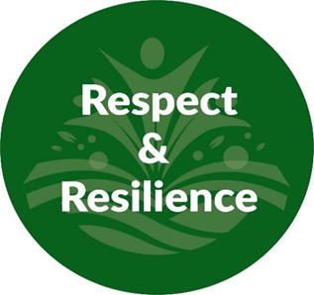 |  |  |  | 
Mental Health and Wellbeing  (Whole School Approach) | 10-a-day Mental Health Choices; https://www.normalmagic.co.uk/resources/10-a-day-2/  Kindness Calendar; https://www.redcross.org.uk/get-involved/teaching-resources/kindness-calendar  Action for happiness; https://actionforhappiness.org/  Normal Magic; https://www.normalmagic.co.uk/  Happy Maps; https://happymaps.co.uk/  Mentally Healthy Schools; https://www.mentallyhealthyschools.org.uk/resources/  Creative education; https://www.creativeeducation.co.uk/  Young Minds; https://www.youngminds.org.uk/ |  |  | 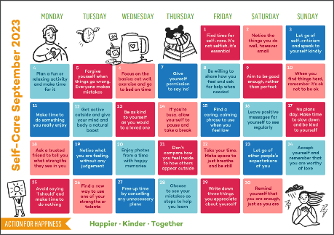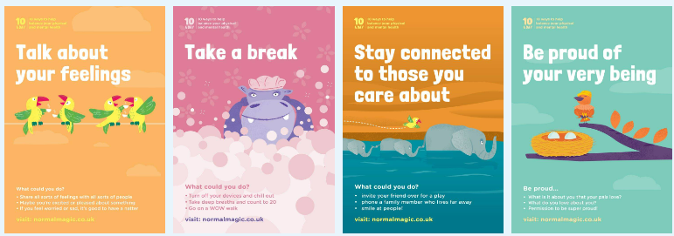
Termly and Assembly Themes | Respect | Resilience | Health | Happiness | Kindness | Independence
Skills Builder  Step 6 |  |  |  |  |    | 
Year 10 | Autumn 1  Another World | Autumn 2  Home is where the Heart is | Spring 1  All families are different! | Spring 2  World War 2 | Summer 1  Mystery in a Foreign Land | Summer 2  Acceptance  & Diversity
Class Novel |  | 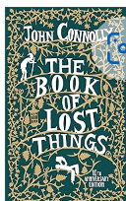 |  |  | 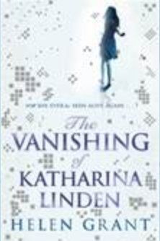 | 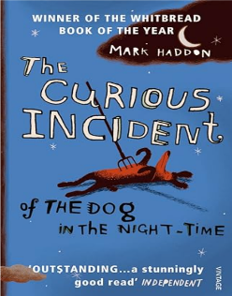
Focus Text | 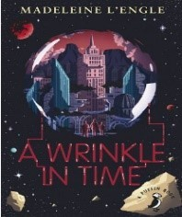 | 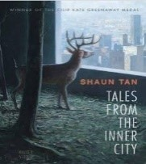  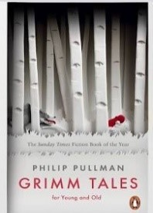 | 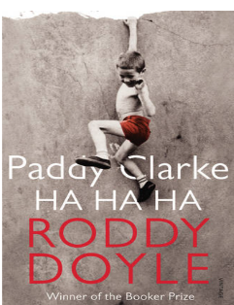 | 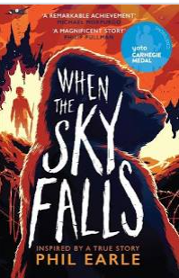 | 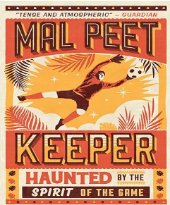 | 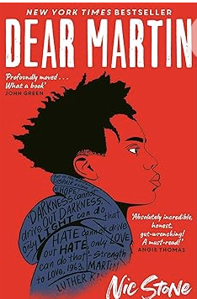
Additional Texts |  |  |  |  | 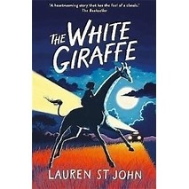 | 
Hybrid Texts | 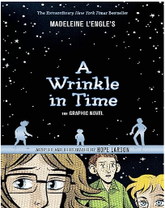 | 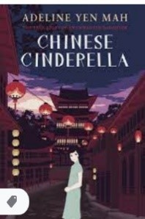 |  | 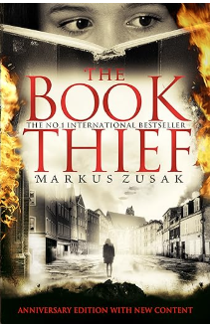 | 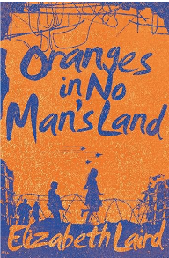 | 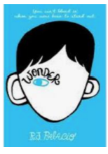
Step Up  Entry Level | Science Fiction  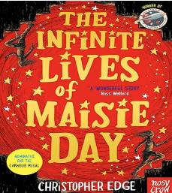 | Hobbies  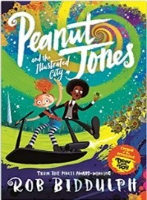 | Style  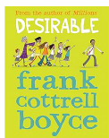 | Music  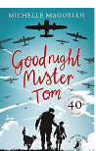 | Myths and Legends  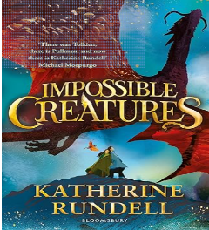 | Heroism  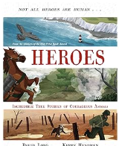
Writing:  Narrative/ Creative | Narrative: Time of Feeling scared  Outcome:  Focus: Setting and Characters | Disaster and Rescue  Outcome: Short story using a starter either: The gates were locked or Someone told a lie  Focus: Rhetorical questions, Endings  Flashback  Creating tension | Adventure Story  Outcome: Short story using a starter either: By the time Dad had started the car or I knew she would never be able to keep it a secret  Focus: Similes and metaphors | Historical Fiction  Outcome: Becoming an Evacuee  Focus: Expanded noun phrases | Suspense Story  Outcome: Short story for KS2 learners  Focus: Dialogue – correctly punctuated | Diary entry  Outcome: Arriving in a foreign land: descriptive writing, feeling and emotions  Focus: First person narrative, emotions and feelings
Writing:  Non-fiction/  Transactional | Journalistic Writing  Outcome: News article Eyewitness account of rocket launch (a robbery) Based on Class Novel Millions, introduction back to school text.  Focus: Rhetorical questions | Presentations about an attraction to visit  Outcome: Presentation using PowerPoint – Truro Christmas Market  Focus: Persuasive language | Persuasive Letter – Family holiday /Family pet  Outcome:  Focus: Commas for sentence of 3 | Newspaper article:  Benefits of taking regular exercise – all schools should have to include an hour of physical exercise every day | Outcome: Travel Review for a magazine  Focus: Bullet points with correct punctuation | Outcome: Speech to Peers using starter ‘Winning is not important it’s about taking part’  Focus: Persuasive language
Writing: Entry Level | Science Fiction  Narrative  Outcome: Science Fiction short story  Focus: Tell it in 5  Eyewitness account of rocket launch  Outcome: News article  Focus: Rhetorical questions | Hobbies  Non-chronological Report  Outcome: Presentation using PowerPoint  Focus: First person  Explanation Text  Outcome: Factsheet  Focus: Organisational devices | Style  Fashion Fact Sheet  Explanation Text  Outcome: How to dye a t-shirt video  Focus: Imperatives, temporal markers  Journalistic Writing  Outcome: Magazine article  Focus: Question stems | Music  Outcome: Letter of application  Focus: Paragraphs  Persuasion  Outcome: Letter to invite a celebrity to launch a radio show  Focus: Persuasive language  Persuasion  Outcome: Radio Show Advert  Focus: Persuasive language | Myths and Legends  Outcome: Comic Strip Retell  Focus: Dialogue  Outcome: Traditional Myth  Focus: Adjectives, complex sentences | Heroism  Outcome: Heroic Story  Focus: Character and Settings, similes  Explanation  Outcome: What makes a hero?  Focus: synonyms
Speaking and Listening | Via the Reading and Writing Curriculum, pupils will be able to;  Speak confidently and effectively, in a range of formal and informal contexts, including classroom discussion. Give short speeches and presentations, expressing their own ideas. Participate in formal debates and structured discussions, summarising and/or building on what has been said. Improvise, rehearse and perform play scripts and poetry in order to generate language and discuss language use and meaning, using role, intonation, tone, volume, mood, silence, stillness and action to add impact.
Maths | Maths  OCR GCSE 1-9 Foundation and Higher  Edexcel Functional Skills Level 1 and Level 2  Edexcel Entry Level Functional Skills
Science: | The Nature and Variety of Organisms | Blood and Organs | DNA and Inheritance | Human Nutrition | Plant Nutrition and Transport | Ecology and Environment
Science: | Particles and Mixtures | Periodic Table and Bonding | Group 1, 7, 0 and Atmospheric Gases | Rate of Reaction and Energetics | Inorganic Chemistry | Hydrocarbons
Science: | Astrophysics | Waves | Forces and Motion | Solids, Liquids and Gases | Electricity | Energy Resources
BTEC Combined Science | Unit A1  Being Organised | Unit ASc12  Investigating Crime Scene Evidence | Unit A2  Developing a Personal Progression Plan | Unit ASc6  Planning a Scientific Experiment | Unit A Sc7  Investigating Variations in  Plants and Animals | Unit A Sc10  Making a Chemical Product
Academic Interventions | Academic Interventions will be implemented where necessary to aid pupil progress, plug gaps in learning and secure good outcomes against individual pupils starting points.  Interventions such as Phonics via RWI, games-based literacy and numeracy interventions, Fun Fit, Touch Typing.
Therapies  SALT Communication & Interaction | Class Reading  Social Situations  Games: Board and Cards: Uno  Team Building  Every pupil can have access to; (*Theraputically inspired interventions, these will be based on individual need, informed by professional advice and parental guidance please see interventions provision map)  Trauma Informed approach  Individually assessed sensory integration regulation activities  TEEACH approach
Word of the Week | Yearn  Serene  Nostalgic  Innovative  Uncanny  Scour | Constrict  Accumulate  Inflate  Diminish  Lucid  Dubious | Perilous  Supercilious  Treacherous  Disposition  Tremor  Perusal | Arduous  Swathe  Derisory  Fleeting  Vigilant  Tremulous | Trajectory  Reciprocate  Poignant  Zeal  Forlorn  Contentious | Enchantment  Misanthropic  Auspicious  Acquire  Periphery  Fractious
Idiom of the Week | Eager Beaver  Down in the dumps  Think outside the box  Bury the hatchet  Money doesn’t grow on trees  On the cards | In a pickle  In the same boat  Achille’s Heel  Put your money where your mouth is  Break a leg  Turn over a new leaf | Put all your eggs in one basket  Cry over spilled milk  On the back burner  Mend fences  Eat humble pie  Jump on the bandwagon | The gloves are off  Midas touch  Hold your horses  Cost an arm and a leg  Throw in the towel  Ball is in your court | Have a lot on your plate  Spill the beans  Take a rain check  Call the shots  Midas touch  In a nutshell | Get cold feet  Piece of cake  Couch potato  A taste of our own medicine  A fish out of water  Money can’t buy happiness
Interoception Curriculum | Section 1 Body | Section 1 Body | Section 1 Body  Section 2 Emotions | Section 2 Emotions | Section 2 Emotions | Section 2 Emotions
Personal Development / PSHE  Online Safety  Project Evolve |    |     Anti-Bullying week: Online bullying  https://anti-bullyingalliance.org.uk/ |   Safer Internet Day: https://saferinternet.org.uk/ |   CSE Awareness Day https://stop-cse.org/national-child-exploitation-awareness-day/ |  |   CSE Awareness Day  https://stop-cse.org/national-child-exploitation-awareness-day
ASDAN Short Course PHSE | EDIT for 24-25: Personal Relationships  Addressing Extremism and Radicalisation  ‘Living in modern Britian’  Communities, belonging and challenging extremism | Exploring Influences –  Drugs and Gangs  The influence and impact of drugs, gangs, role models and the media | Mental health –  Emotional Wellbeing  Mental health and ill health, stigma, safeguarding health, including during periods of transition or change | Healthy relationships –  Sexual Health  Relationships and sex expectations, pleasure and challenges, including the impact of the media and pornography | Financial Decision Making  Financial Choices  The impact of financial decisions, debt, gambling and the impact of advertising on financial choices | Next steps  Careers and your Future  Work Experience  Application processes, and skills for further education, employment and career progression
Personal Development /  PSHE including; National Awareness  Protected Characteristics | Great British Beach Clean 2024  World - Let's Stop Shouting Day 2024  Health & Wellbeing -  Age | Anti bullying Week; https://anti-bullyingalliance.org.uk/  Relationships – Diversity  Sex  Sexual Orientation | Safer Internet Day; https://www.saferinternetday.org/  CSE awareness day; https://stop-ce.org/national-child-exploitation-awareness-day/  Relationships – Building Relationships Marriage and Civil Partnerships  Gender Re Assignment Pregnancy and Maternity | Health & Wellbeing – Health & Puberty  Race | Living in the wider world – Financial Decision Making  Disability | Living in the wider world – Developing skills & Aspirations  Personal Safety  Religion and Beliefs
PSHE  Protected Characteristics | Race   | Sex    Sexual Orientation   | Marriage and Civil Partnerships    Pregnancy and Maternity   | Age    Gender Reassignment   |   Disability | Religion and Beliefs  
PSHE  British Values | Mutual Respect |  | Rule of Law | Individual Liberty | Tolerance | Democracy
ASDAN PD Silver | Module 7  Health and Wellbeing | Module 1  Communication | Module 9  Science and Technology | Module 4  Independent Living | Module 6  Number Handling | Module 2  My Community
Careers | Develop  Making decisions – An in depth look at post 16 education and providers.  Trip to Penventon Hotel Redruth to view all aspects of hotel industry employment  GB2 GB6 GB5 GB7 | Develop  Employability Skills – How can I develop my skills for the future?  Careers Meeting with Adviser  GB1 GB3 GB8  College Open Events | Develop  Preparing for my future Updating my CV and interview techniques.  GB2 GB5 GB6 | Develop  ASDAN PSHE Module 10 Careers and your future  RLS Careers Fair / Business enterprise involvement participation | Develop  ASDAN PSHE Module 10 Careers and your future  Work Experience Opportunities | Develop  ASDAN PSHE Module 10 Careers and your future  Skills builder Challenge Day
Computing / FS ICT Level 1 and 2 | Managing Information |  | Using Data |  | Presentation and communication of information
RE  ASDAN Short Course Beliefs & Values | Crime and punishment |  | Values, Beliefs and Decision Making |  | Beliefs and Practice
BTEC Home Cooking Skills level 1 & 2 | What will you choose for breakfast? | Sweet or Savoury, Pastries & Breads | We prefer Italian! | Rice & Potato Dishes | What’s for dinner?  BBQ Style | Salads and Dressings
WJEC Hospitality & Catering | Hygiene and Safety  (Unit 1 and 2) | Hygiene and Safety  (Unit 1 and 2)  Understanding the importance of nutrition  (Unit 2) | Factors affecting Dishes  (Unit 1 and 2)  Understanding the importance of nutrition  (Unit 2) | Customer requirements in the Hospitality Industry  (Unit 1 and Unit 2) | Planning, cooking and serving dishes  (Unit 2)  Unit 2 Moc | The Hospitality Industry  (Unit 1)  Planning, cooking and serving dishes  (Unit 2)
Humanities | World History  Conflict and tension between the Gulf and Afghanistan 1990 – 2009 | Physical Geography  Natural Hazards  Haiti earthquake and the impact on a poorer country | Physical Geography  Natural hazards  Case study – Japan earthquake and its impact on a wealthy country | World History  America 1920 – 1973, opportunity and inequality, black equality, slavery | British History  Elizabethan England 1568 - 1603 | Geographical Enquiry  Locational Knowledge  Case study – Cornwall NORTH COAST) and the coastal erosion.
Art  (Year 9) | The world around me: Street / local area observations: Banksy, and other street artists. Mixed media project. |  | An exploration of Fauvism: Henri Matisse  Students can choose to explore landscapes or self-portrait based on the theme. |  | 3D Sculptural exploration from Cornish Landscapes:  Peter Lanyon
GCSE Art, Craft and Design | AO1 / AO2  Project 1: Workshops in: Lino Printing, collage and Line Drawing  Angie Lewin, Henri Matisse, Paul Klee.  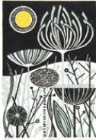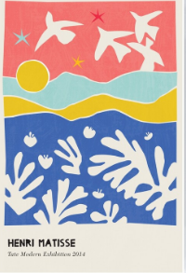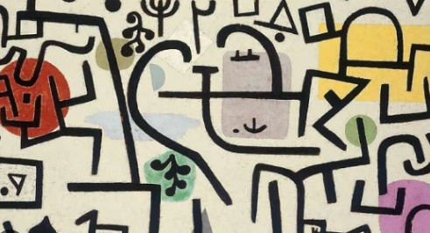 |  | AO1 / AO2 Project 2: Workshops in:  Basquait, Picasso, Lucian Freud  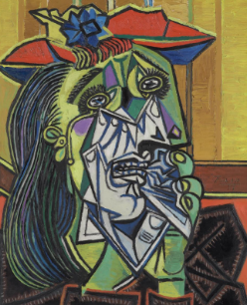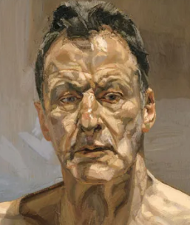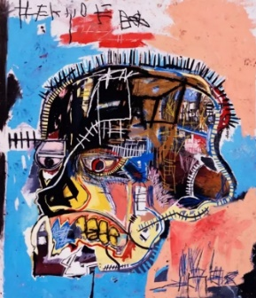 |  | Completion of Project 2 with a focus on AO4
PE | Games: Net and Striking: Badminton  Invasion Games: Football | Fitness  Circuit Training  Invasion Games: Basketball | Fitness  Circuit Training  Net & Wall Games: Table Tennis | Invasion Games: Tag Rugby  Target Games: Ultimate Frisbee | Games: Striking and Fielding  Rounders  Net & Wall Games: Tennis | Athletics: Running, throwing, jumping
Outdoor Education | Team building / Communication and Interaction  Local walks / Forest skills  Forest School  Shelter building, cooking, survival skills  Forest School  Team building challenges  Indoor Swimming /  Coastal Swimming  Forest School  Shelter building, cooking, survival skills  Training – navigation & teamwork focus  Water Adventures  Wild Swimming-Beach & River  SUP/ Canoe  Outdoor Education Learning Award |  |  | Forest School  Team building challenges  Indoor Swimming /  Coastal Swimming  Forest School  Shelter building, cooking, survival skills  Training – navigation & teamwork focus |  | Water Adventures  Wild Swimming-Beach & River  SUP/ Canoe  Outdoor Education Learning Award

