

CCS Careers Policy

February 2025

Contents
1. Aims 3
2. Roles and Responsibilities 3
3. Our Careers Curriculum 5
Key Stage 2 6
Key Stage 3 7
Key Stage 4 7
4. Links to other policies 8
5. Monitoring and review 8
Appendices
1: Statutory Requirements
2: Career Pathways

1: Aims
This policy aims to set out our school’s curriculum alongside our provision of impartial and informed careers guidance for our learners. This includes the ways in which learners, parents, teachers and employers can access information about our careers programme.
High-quality careers guidance is important for our learners’ futures, and our provision aims to:
- Help learners prepare for the workplace, by building self-development and career management skills
- Provide experience and a clear understanding of the working world
- Endeavour to ensure that every learner feels that they have the potential to pursue their chosen career
- Develop learners’ awareness of the variety of education, training and careers opportunities available to them
- Help learners to understand routes to careers that they’re interested in, and to make informed choices about their next step in education or training
- Promote a culture of high aspirations and equality of opportunity

2: Roles and Responsibilities
2.1 Careers leader
Our careers leader is Kerry Towers, and she can be contacted via or email: ktowers@cardrewcourt.org
Our careers leader is a member of the Senior Leadership Team (SLT) and:
- Is Responsible for developing, running and reporting on the school’s career programme
- Plans and manages careers activities including the school’s careers fair
- Monitors and evaluates the careers curriculum – including updating content
- Supports teachers to build careers education and guidance into subjects across the curriculum
- Establishes and develops links with employers, education and training providers, and careers organisations
- Work closely with our Wellbeing Practitioner to ensure there are personalised transition plans for those learners who require them.
- Work with our school's Designated Teacher for Looked-After Children (LAC) and previously LAC to:
- Make sure they know which learners are in care or are care leavers
- Understand their additional support needs
- Make sure that, for LAC, their personal education plan can help inform careers advice
- Review our school's Provider Access policy statement at least annually, in agreement with our governing body
2.2 Senior Leadership Team (SLT)
Our SLT will:
- Support the careers programme
- Support the careers leader in developing their strategic careers plan
- Make sure our school’s careers leader is allocated sufficient time, and has the appropriate training, to perform their duties to a high standard
- Allow training providers access to talk to learners in years 8 to 11 about technical education qualifications and apprenticeships, and set out arrangements for this in our school’s provider access policy statement
- Network with employers, education and training providers, and other careers organisations
2.3 The Governing Body
The Governing Body will:
- Provide clear advice and guidance on which the school can base a strategic careers plan which meets legal and contractual requirements
- Appoint a member of the governing board who will take a strategic interest in careers education and encourage employer engagement
- Make sure independent careers guidance is provided to all learners throughout their secondary education (11- to 16-year-olds) and that the information is presented impartially, includes a range of educational or training options and promotes the best interests of learners
- Make sure that a range of education and training providers can access learners in years 8 to 11 to inform them of approved technical education qualifications and apprenticeships
- Make sure that details of our school’s careers programme and the name of the career’s leader are published on the school’s website
- Make sure that arrangements are in place for the school to meet the legal requirements of the ‘Baker Clause’, including that the school has published a Provider Access policy statement.

3: Careers Curriculum
3.1 Overview
Our school has an embedded careers programme that aims to not only inform and encourage learners to consider their career options and take steps to understand their choices and pathways. It also supports the development of employability skills.

We provide statutory independent careers guidance to learners from KS2 inwards.
Our programme has been developed to meet the expectations outlined in the Gatsby Benchmarks:
- A stable careers programme with a career’s leader
- Learning from career and labour market information
- Addressing the needs of each pupil
- Linking curriculum learning to careers
- Encounters with employers and employees
- Experience of workplaces
- Encounters with further and higher education
- Personal guidance
Our curriculum doesn’t show bias towards any particular career path and promotes a full range of technical and academic options for learners.
It is structured in a way that builds upon previous years, and the overarching aim is divided between the Key Stages so that learners are encouraged to think appropriately about their future. We provide objectives and activities for each year group along with skills progression.
Our Careers Curriculum, informed by the Gatsby Benchmarks, notifies learners of potential career opportunities and the necessary skills/qualifications required to achieve their future career pathway. We facilitate learning using the ‘The Skills Builder’ hub to develop and monitor key skills needed for employment, encouraging our learners to have high and realistic aspirations to achieve personal success and economic wellbeing. Our careers program highlights the breadth of options that are available to our learners, whilst offering a curriculum designed to meet their individual needs.
- Careers lessons are delivered during the final two weeks of each half term; however, the careers programme is embedded throughout our curriculum.
- Guest speakers and local employers are invited throughout the school year to explain the opportunities and their experiences of finding employment.
- Representatives from further education colleges and National Apprenticeships events coordinate bespoke opportunities for our students to attend additional open days.
- Displays are regularly updated to promote events, college open days and pathways to careers, including contact details.
- The curriculum encourages teachers and students to explore their community and build real world experiences of employability.

3.2 Key Stage 2
Our Key Stage 2 careers programme supports learners in their understanding and development of transferrable skills that can be used in different learning environments. This includes developing learners' knowledge of:
- Employability skills using the Skills Builder Toolkit.
- The different job sectors, locally, nationally and internationally.
- Citizenship and what it means to be a good citizen.
- Job roles, including experiences and to link the skills required to complete them.

3.3 Key Stage 3
Our Key Stage 3 careers programme supports students in making choices of their GCSE subjects and entry level pathways. This includes:
- Exploring career roles and links to their own personal interests.
- Developing their knowledge of employability skills using the Skills Builder Toolkit and the 8 essential strands to succeed.
- Supporting learners to research and prepare for upcoming careers events in their community, using their developing skills to communicate with a variety of providers.
- Learners investigating varying job sectors, locally, nationally and internationally, whilst researching the skills needed for future job sectors.
- Learners are given the opportunity to explore and link the importance of employees’ rights and mental wellbeing with job satisfaction.

3.4 Key Stage 4
Our Key Stage 4 careers programme aims to help learners research and develop their knowledge of possible choices and routes into education and training. This includes:
- Researching, identifying and sourcing work experience placements, developing the skills needed to be successful in employment and review their skillset.
- Developing their knowledge of different career pathways, relating their skills and progression through education with employment opportunities.
- Learners’ attendance at events and open days at colleges and universities to source personalised pathways.
- Develop learner’s skills specifically looking at the different skills needed for work and the 8 essential strands to succeed.
- Develop learners' knowledge of employer and employee rights, taxes, managing income/expenditure and sourcing advice in the workplace.

4: Access to our Careers Curriculum Information
A summary of our school’s careers curriculum is published on our school website, including details of how learners, parents, teachers and employers can access information about the careers programme.
Learners, parents, teachers and employers can request any additional information about the careers programme by contacting the Careers lead via email: ktowers@cardrewcourt.org
5: Assessing the Impact on Learners
Our Careers curriculum is designed so learners can give feedback, and their progress measured as they move through the Key Stages. We measure and assess the impact of the programme’s initiatives by:
- Utilising the Skills Builder 8 essential skills and measuring the steps of progress in each skill.
- The Careers Lead meeting termly with teachers to discuss, evaluate and develop the curriculum,
- Inviting all stakeholders to the careers fair and seeking their feedback.
- Publishing all the careers specific activities that students have been experiencing and the dates and relevant contacts of upcoming events.
- Ensuring learners in years 10 and 11 attend careers interviews with a career's specialist from ‘Careers Southwest’ (CSW), to discuss their personalised pathway into the world of work.
- Reviewing the success of the Careers Curriculum annually and identifying further developments.

6: Links to Other Policies

This policy links to the following policies
- Provider Access Policy Statement
- Safeguarding Policy
- Curriculum Policy

7: Monitoring and Review

This policy, the information included, and its implementation will be monitored by the Careers Lead / Headteacher Kerry Towers reviewed annually with the support of SLT.

Appendix 1

Statutory Requirements
This policy is based on the Department for Education’s (DfE’s) statutory Careers guidance and access for education and training providers.
This guidance refers to:
- The Education Act 1997
- The Education and Skills Act 2008
- The School Information (*England) Regulations 2008
This policy is also in line with the more recent Skills and Post-16 Act 2022, which came into force on 1 January 2023. It explains that our school must provide a minimum of 6 encounters with technical education or training providers to all learners in years 8 to 13. For more detail on these encounters, see our provider access policy statement, which you can find on our school website.
This policy is also in line with the Education (Careers Guidance in Schools) Act 2022. This came into force on 1 September 2022, and amended the existing duty in The Education Act 1997, so that:
- Our school must now secure independent careers guidance from year 7 (instead of from year 8, previously)

We also act in line with our statutory duty under the ‘Baker Clause’, to be impartial and not show bias towards any route, be that academic or technical. This policy should be read in conjunction with our provider access policy statement, which sets out how our school meets this duty, and can be found on our school website.
Appendix 2
Careers Pathway Diagram

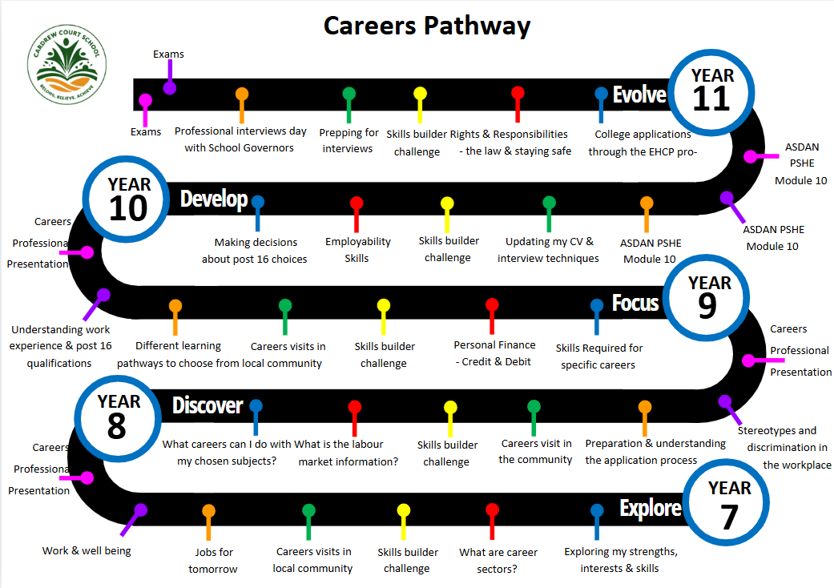

Careers Pathway KS2


